**Name:** Gunjan Jhawar

**Subject code:** EE 511

**USCID:** 1857534264

**Project: 4**

**Problem Statement:**

1. Toss a coin for 50 times, find:

(i) Number of heads.

(ii) Length of longest heads

1. Toss a coin 5000 repetition, find:
2. First time Head occurs
3. First time two head occur
4. First time three head occur
5. First time four head occur
6. Frequency distribution of all

**Brief description of experiment:**

1. Coin is tossed using a fair coin 50 times. Each time head occur value of variable no_of_heads is increased by 1. All the length of heads is noted and stored in an array. Then the longest value in that array is assigned to length which is the length of the longest head.
2. Coin is tossed for 50 times and the first time a head occurs is stored in S1. Similarly, first time two head occur is stored in S2. Similar way S3 and S4 are computed. This experiment is repeated 5000 times.The frequency distribution for S1,S2,S3 and S4 are plotted..

**Summary of Results:**

The distribution found shows occurs of S3 and S4 around 50. It can be concluded that for large data the probability of head and tail occurring is near 0.5.

**Relevant Graphs:**

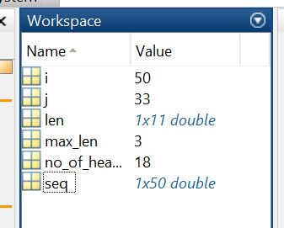 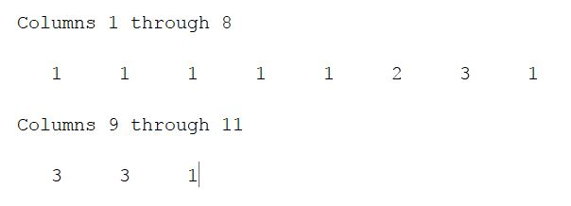

Figure 1 Figure 2



Figure 3

Code A)

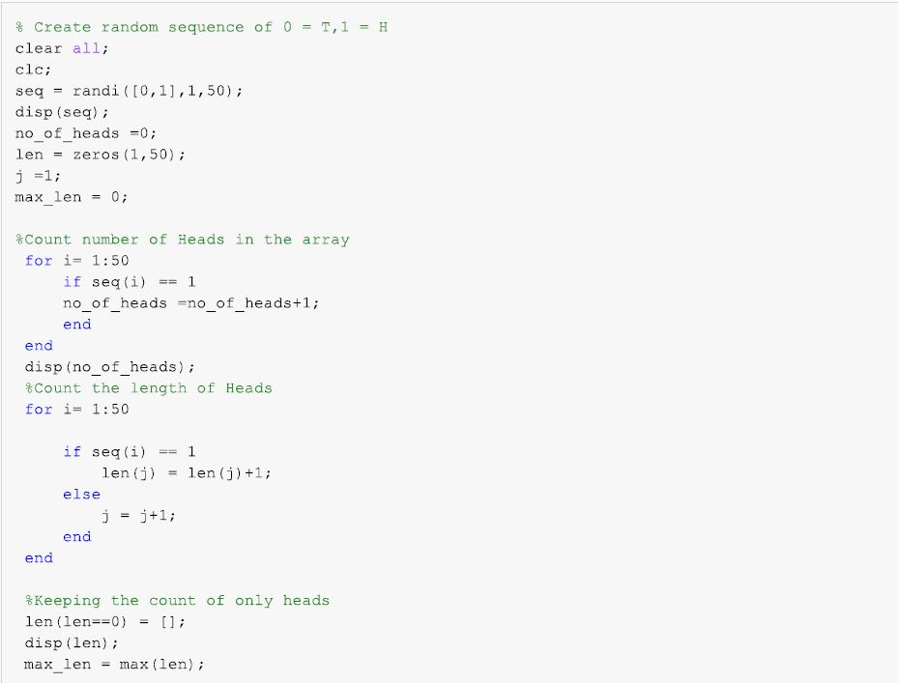

Code B)

